Section I: Scenario Demographics

Scenario Title: | Vital-Signs-Absent (VSA) Megacode
Date of Development: | 25/04/2015 (DD/MM/YYYY)
Target Learning Group: | Juniors (PGY 1 – 2) Seniors (PGY ≥ 3) All Groups

Section II: Scenario Developers

Scenario Developer(s): | Cheryl ffrench
Affiliations/Institution(s): | University of Manitoba
Contact E-mail (optional): | emerg13@gmail.com

Section III: Curriculum Integration

Learning Goals & Objectives
Educational Goal: | To provide learners with the opportunity to manage a prolonged resuscitation that requires strong resource allocation skills.
CRM Objectives: | - Communicate clearly and lead team through a lengthy resuscitation.  - Recognize compression fatigue in team members and find ways to engage or relieve fatigued members
Medical Objectives: | - Provide quality ACLS care, including:  - Expedient defibrillation for a shockable rhythm  - Appropriate use of ACLS medications  - Use of ETCO2 to guide resuscitation  - Minimizing pulse checks  - Appropriate 30:2 ratio of compressions to breaths prior to intubation  - Initiate appropriate post-arrest care, including PCI.

Case Summary: Brief Summary of Case Progression and Major Events
A 54-year-old male police officer presents to the ED complaining of chest pain for two hours that started after his weekend hockey game. He is feeling dizzy and short of breath upon presentation. He will have a VT arrest as he is placed on the monitor. He will require two shocks and rounds of CPR before he has ROSC. He will then loose his pulse again while the team is trying to initiate post-arrest care; This will happen several times. Finally, the team will maintain ROSC. When an ECG is performed, it is revealed that the patient has a STEMI and the team will need to call for emergent PCI.

References
Marx, J. A., Hockberger, R. S., Walls, R. M., & Adams, J. (2013). Rosen's emergency medicine: Concepts and clinical practice. St. Louis: Mosby.

Section IV: Scenario Script

A. Scenario Cast & Realism
Patient: | Computerized Mannequin |  |  |  |  | Realism:  Select most important dimension(s) |  |  | Conceptual
Patient: | Mannequin |  |  |  |  |  |  |  | Physical
Patient: | Standardized Patient |  |  |  |  |  |  |  | Emotional/Experiential
Patient: | Hybrid |  |  |  |  |  |  |  | Other:
Patient: | Task Trainer |  |  |  |  |  |  |  | N/A
Confederates | Brief Description of Role
None.
B. Required Monitors
EKG Leads/Wires |  |  | Temperature Probe |  |  |  | Central Venous Line
NIBP Cuff |  |  | Defibrillator Pads |  |  |  | Capnography
Pulse Oximeter |  |  | Arterial Line |  |  |  | Other:
C. Required Equipment
Gloves |  |  | Nasal Prongs |  |  |  | Scalpel
Stethoscope |  |  | Venturi Mask |  |  |  | Tube Thoracostomy Kit
Defibrillator |  |  | Non-Rebreather Mask |  |  |  | Cricothyroidotomy Kit
IV Bags/Lines |  |  | Bag Valve Mask |  |  |  | Thoracotomy Kit
IV Push Medications |  |  | Laryngoscope |  |  |  | Central Line Kit
PO Tabs |  |  | Video Assisted Laryngoscope |  |  |  | Arterial Line Kit
Blood Products |  |  | ET Tubes |  |  |  | Other:
Intraosseous Set-up |  |  | LMA |  |  |  | Other:
D. Moulage
None required.

E. Approximate Timing
Set-Up: |  | 3 min |  | Scenario: | 20 min |  |  | Debriefing: |  | 20 min

Section V: Patient Data and Baseline State

A. Clinical Vignette: To Read Aloud at Beginning of Case
A 54-year-old male police officer presents to the ED with chest pain. He played his normal weekend hockey game about two hours ago. He has been having retrosternal chest pain since the game ended. It improved with rest, but has not resolved completely. It is worse after walking into the department. He now feels dizzy, short of breath, and nauseous.
B. Patient Profile and History
Patient Name: Richard Green |  |  |  |  |  | Age: 54 |  |  |  |  |  |  |  | Weight: 75kg
Gender: M F |  |  |  |  |  | Code Status: Full.
Chief Complaint: Chest pain
History of Presenting Illness: Played his usual weekend hockey game about 2 hours ago. Developed chest pain after the hockey game. It got better after he rested for a bit, but never really went away.
Past Medical History: |  | None. |  |  |  |  | Medications: |  |  |  |  | None.
 |  | No history of CP.
Allergies: None.
Social History: Non-smoker. Works as police officer.
Family History: None obtained.
Review of Systems: |  | CNS: |  |  | Feels dizzy on arrival.
 |  | HEENT: |  |  | Nil.
 |  | CVS: |  |  | Chest pain (heaviness) x2 hours. Retrosternal, radiates to L arm.
 |  | RESP: |  |  | Feels SOB from walking into department.
 |  | GI: |  |  | Mild nausea.
 |  | GU: |  |  | Nil.
 |  | MSK: |  |  | Nil. |  |  |  |  |  |  |  | INT: |  | Nil.
C. Baseline Simulator State and Physical Exam
No Monitor Display |  |  |  | Monitor On, no data displayed |  |  |  |  |  |  | Monitor on Standard Display
HR: 74/min |  |  | BP: 100/60 |  |  |  |  | RR: 12/min |  |  |  |  |  |  | O₂SAT: 96% RA
Rhythm: NSR |  |  | T: 36.6ºC |  |  |  |  | Glucose: 5.8 mmol/L |  |  |  |  |  |  | GCS: 15 (E4 V5 M6)
General Status: Looks unwell.
CNS: | A+Ox3. No focal deficits.
HEENT: | Nil.
CVS: | No murmur. PPPx4, no pulse differentials.
RESP: | GAEB. No adventitious.
ABDO: | Soft, NT.
GU: | Nil.
MSK: | Nil. |  |  |  |  |  |  |  | SKIN: | Diaphoretic

Scenario States, Modifiers and Triggers
Patient State | Patient Status | Learner Actions, Modifiers & Triggers to Move to Next State
1. Baseline State  Rhythm: NSR  HR: 74/min  BP: 100/60  RR: 12/min  O₂SAT: 96% RA  T: 36.6ºC | A+O. Diaphoretic. Complaining of increased CP, SOB, dizzy. | Learner Actions  - IV, O2, monitors  - ECG (not given)  - Cardiac blood work  - History and Physical  - ASA 160mg PO chew  - Nitro spray | Modifiers  Changes to patient condition based on learner action  - Nitro spray BP 80/40  Triggers  For progression to next state  - 2min 2. VT arrest
2. VT arrest  Rhythm VT  HR 180  BP -/-  O₂SAT 74%  ETCO₂ 10 | Patient unconscious and pulseless. | Learner Actions  - Quality CPR (30:2 until intubation)  - Defibrillate VT  - Epinephrine 1amp q3min  - Amiodarone 300mg  - HCO3 and CaCl amps  - Intubate  - Monitor capnography | Modifiers  - 1st shock stays in VT  - Quality CPR: ETCO2 16  - Poor CPR: ETCO2 8  Triggers  - 2nd shock 3. Temporary ROSC
3. Temporary ROSC  Rhythm junctional  HR 55  BP 85/45  O₂SAT 95%  ETCO₂ 40 | Patient opens eyes to voice. | Learner Actions  - Ask for ECG (not given)  - Check BP and other vitals  - Fluid bolus  - Norepi or epi infusion  - Initiate cooling | Triggers  - 1 min into state 1st time  4. VF arrest  - 1 min into state 2nd time  5. PEA arrest
4. VF arrest  Rhythm VF  HR 180  BP -/-  O₂SAT 68%  ETCO₂ 10 | Patient unconscious and pulseless. | Learner Actions  - Quality CPR  - Defibrillate VF  - Epinephrine 1amp q3min  - Amiodarone 300mg  - HCO3 and CaCl amps  - Intubate (if not yet)  - Monitor capnography | Modifiers  - 1st shock stays in VF  - Quality CPR: ETCO2 16  - Poor CPR: ETCO2 8  Triggers  - 2nd shock 3. Temporary ROSC
5. PEA arrest  Rhythm slow PEA  HR 20  BP -/-  O₂SAT 68%  ETCO₂ 10 | Patient unconscious and pulseless. | Learner Actions  - Quality CPR  - Epinephrine 1amp q3min  - HCO3 and CaCl amps  - Intubate (if not yet)  - Monitor capnography | Modifiers  - Quality CPR: ETCO2 16  - Poor CPR: ETCO2 8  Triggers  - 3 rounds or 18 min 6. ROSC
6. ROSC  Rhythm STEMI NSR  HR 55  BP 85/45  O₂SAT 96%  RR 12 (vented)  ETCO₂ 40 | Patient nonresponsive but has pulse | - ECG, check cap sugar (6.2)  - Norepi or epi infusion  - Initiate cooling  - CXR  - Call cath lab  - OG for ASA/ticagrelor  - Heparin 4000 units iv | Modifiers  - Vasopressor started BP 95/65  Triggers  - 20 min or cath lab called End Case
Section VI: Scenario Progression

Section VII: Supporting Documents, Laboratory Results, & Multimedia

Laboratory Results
No blood work given in this case.

Images (ECGs, CXRs, etc.)
ECG Post ROSC: anterolateral STEMI  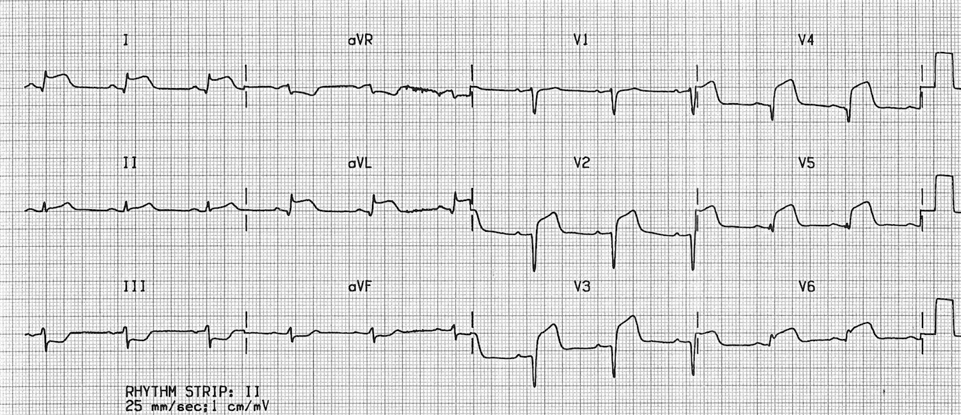  (ECG source: http://cdn.lifeinthefastlane.com/wp-content/uploads/2011/10/anterolateral.jpg) | CXR post ROSC: normal post-intubation CXR  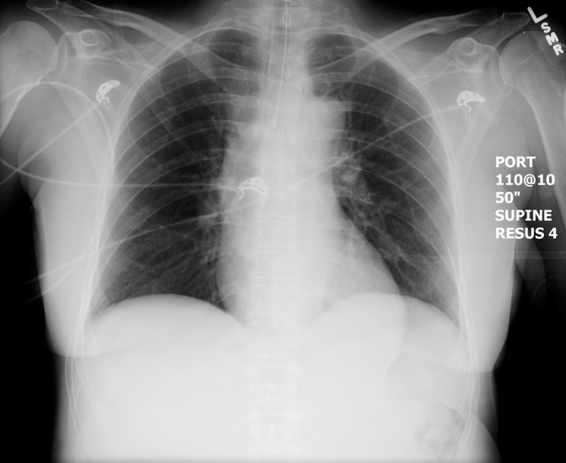  (CXR source: https://emcow.files.wordpress.com/  2012/11/normal-intubation2.jpg)

Section VIII: Debriefing Guide

General Debriefing Plan
Individual | Group |  | With Video | Without Video
Objectives
Educational Goal: |  | To provide learners with the opportunity to manage a prolonged resuscitation that requires strong resource allocation skills.
CRM Objectives: |  | - Communicate clearly and lead team through a lengthy resuscitation.  - Recognize compression fatigue in team members and find ways to engage or relieve fatigued members
Medical Objectives: |  | - Provide quality ACLS care, including:  - Expedient defibrillation for a shockable rhythm  - Appropriate use of ACLS medications  - Use of ETCO2 to guide resuscitation  - Minimizing pulse checks  - Appropriate 30:2 ratio of compressions to breaths prior to intubation  - Initiate appropriate post-arrest care, including PCI.
Sample Questions for Debriefing
- How did it feel to have your resuscitation intermittently produce ROSC?
- This was a long and frustrating case. Did you consider the fatigue of team members? What was your strategy to address fatigue?
- Were you using ETCO2 to assess compression quality and ROSC? How is ETCO2 helpful?
- How and when do you initiate therapeutic hypothermia after a cardiac arrest? When is it contraindicated?
Key Moments
Recognition of loss of pulse
Recognition of ROSC and then repeated pulse loss
Recognition of STEMI and calling cath lab

