Section I: Scenario Demographics

Scenario Title: | Pediatric viral myocarditis with cardiogenic shock
Date of Development: | January 26, 2017
Target Learning Group: | Juniors (PGY 1 – 2) Seniors (PGY ≥ 3) All Groups

Section II: Scenario Developers

Scenario Developer(s): | Adam Cheng, modified by Dawn Lim, Andrea Somers, Nadia Farooki
Affiliations/Institution(s): | University of Toronto, University Health Network
Contact E-mail (optional): | nadiafarooki@icloud.com

Section III: Curriculum Integration

Learning Goals & Objectives
Educational Goal: | To allow learners to practice identifying and managing cardiogenic shock in a critically ill adolescent
CRM Objectives: | - Demonstrates situational awareness by avoiding fixation error in a dynamic clinical situation  - Problem solving: considers alternative etiologies of shock when the patient is unresponsive to initial treatment
Medical Objectives: | - Recognizes a critically ill adolescent with cardiogenic shock  - Recalls and works through broad differential diagnosis of persistent hypotension  - Performs safe intubation  - Manages cardiogenic shock with inotropes

Case Summary: Brief Summary of Case Progression and Major Events
A 15 year-old male with no prior medical history is brought to the ED by his parents for lethargy, shortness of breath and chest pain. He was feeling run down for the past 4 days with URTI symptoms.

His initial presentation looks like sepsis with a secondary bacterial pneumonia. He becomes hypoxic requiring intubation. He develops hypotension that does not respond as expected to fluids and vasopressors, which should prompt more diagnostics from the team.

Further testing reveals cardiomyopathy with reduced EF and acute CHF. He finally stabilizes with inotropes and diuresis.

References
Marx, J. A., Hockberger, R. S., Walls, R. M., & Adams, J. (2013). Rosen's emergency medicine: Concepts and clinical practice. St. Louis: Mosby.
Up to Date (Pediatric Myocarditis)

Section IV: Scenario Script

A. Scenario Cast & Realism
Patient: | Computerized Mannequin |  |  |  |  | Realism:  Select most important dimension(s) |  |  | Conceptual
Patient: | Mannequin |  |  |  |  |  |  |  | Physical
Patient: | Standardized Patient |  |  |  |  |  |  |  | Emotional/Experiential
Patient: | Hybrid |  |  |  |  |  |  |  | Other:
Patient: | Task Trainer |  |  |  |  |  |  |  | N/A
Confederates | Brief Description of Role
ED RN  ED RT | Acts as experienced ED RN  To assist with intubation, ask re: initial vent settings
B. Required Monitors
EKG Leads/Wires |  |  | Temperature Probe |  |  |  | Central Venous Line
NIBP Cuff |  |  | Defibrillator Pads |  |  |  | Capnography
Pulse Oximeter |  |  | Arterial Line |  |  |  | Other:
C. Required Equipment
Gloves |  |  | Nasal Prongs |  |  |  | Scalpel
Stethoscope |  |  | Venturi Mask |  |  |  | Tube Thoracostomy Kit
Defibrillator |  |  | Non-Rebreather Mask |  |  |  | Cricothyroidotomy Kit
IV Bags/Lines |  |  | Bag Valve Mask |  |  |  | Thoracotomy Kit
IV Push Medications |  |  | Laryngoscope |  |  |  | Central Line Kit
PO Tabs |  |  | Video Assisted Laryngoscope |  |  |  | Arterial Line Kit
Blood Products |  |  | ET Tubes |  |  |  | Other: Difficult airway cart
Intraosseous Set-up |  |  | LMA |  |  |  | Other: BiPAP machine
Other: Nebulizer
D. Moulage
Adult mannequin sitting-up, gown on with pants, monitor not attached, one IV in place.

E. Approximate Timing
Set-Up: |  | 3 min |  | Scenario: | 12 min |  |  | Debriefing: |  | 15 min

Section V: Patient Data and Baseline State

A. Clinical Vignette: To Read Aloud at Beginning of Case
You are working in a large community ED. The charge nurse tells you: “EMS have just arrived with a 15-year old boy with shortness of breath and chest pain. His O2 sat is low. EMS have administered oxygen and IVF en route. He looks unwell so I put him in a resuscitation room. Can you see him immediately?”
B. Patient Profile and History
Patient Name: Finn O’Connor |  |  |  |  |  | Age: 15 |  |  |  |  |  |  |  | Weight: 50 kg
Gender: M F |  |  |  |  |  | Code Status: Full
Chief Complaint: Chest pain and SOB
History of Presenting Illness: (provided by RN or sim tech)
Finn is previously healthy, but has had a viral URTI for the past few days. Many classmates have similar symptoms. He had a fever of 39 degrees yesterday. This morning he complained of increasing shortness of breath and chest pain. His family was concerned about his pallor, lack of energy, and decreased appetite. EMS reported vitals are HR 130, RR 30, O₂ Sat 84% on room air, BP 110/70.
Past Medical History: |  | None |  |  |  |  | Medications: |  |  |  |  | None
Allergies: Latex
Social History: High school student, captain of the basketball team. No history of drug use. No history of mental health issues.
Family History: None contributory
Review of Systems: |  | CNS: |  |  | Nil
 |  | HEENT: |  |  | Sore throat
 |  | CVS: |  |  | Chest pain since this morning.
 |  | RESP: |  |  | Short of breath since this morning.
 |  | GI: |  |  | Nil
 |  | GU: |  |  | Nil
 |  | MSK: |  |  | Nil.
C. Baseline Simulator State and Physical Exam
No Monitor Display |  |  |  | Monitor On, no data displayed |  |  |  |  |  |  | Monitor on Standard Display
HR: 130/min |  |  | BP: 100/70mmHg |  |  |  |  | RR: 30/min |  |  |  |  |  |  | O₂ Sat: 92% on NRB
Rhythm: Sinus Tach |  |  | T: 38 degrees |  |  |  |  | Glucose: 7.5mmol/L |  |  |  |  |  |  | GCS: 14 (E3 V5 M6)
General Status: Toxic looking, lethargic
CNS: | Drowsy, but responsive
HEENT: | Erythematous pharynx
CVS: | Sinus tachycardia, S3, mitral regurg murmur
RESP: | Bilateral crackles, increased work of breathing, 2-3 word sentences
ABDO: | Normal
GU: | Normal
MSK: | Cool extremities |  |  |  |  |  |  |  | INT: | Pale

Section VI: Scenario Progression

Scenario States, Modifiers and Triggers
Patient State | Patient Status | Learner Actions, Modifiers & Triggers to Move to Next State
1. Baseline State  Rhythm: sinus tachycardia  HR: 130/min  BP: 110/70  RR: 30/min  spO₂ : 92% NRB  T: 38.0ºC | Drowsy, but rousable.  Laboured breathing.  Diaphoretic. Confederate RN to state “did you notice how cold his legs are?” | Learner Actions  - History & physical  - IV, O₂, monitors  - Glucose check (7.5)  - Appropriate PPE  - Broad spectrum Abx  - Labs: sepsis/tox/blood Cx/troponin  - IV saline bolus  - CXR  - ECG  - ± POCUS | Modifiers  Changes to patient condition based on learner action  Triggers  For progression to the next state  All actions complete or 5 min into the case 2. Hypoxia
2. Hypoxia  HR 140  BP 90/60  RR 35  spO₂ 82% (slow drop) | Breathing more labored.  More drowsy.  SpO₂ starts dropping despite management | Learner Actions  - Call RT  - Second IV (if not done)  - BVM +/- nasal prongs for apneic oxygenation  - Airway assessment  - Ask for RSI meds  - Intubation | Modifiers  - If hypoxia is not noticed, RN to say “I think he is becoming more drowsy and his stats are dropping”  Triggers  Intubation 3. Hypotension
3. Hypotension  HR 140  BP 80/50 70/40 (automatic drop over 2 min)  RR 12  spO₂ 95% (intubated) | Acute drop in BP | Learner Actions  - Vasopressor (norepi/phenylephrine)  - CXR  - POCUS  - Verbalize vent settings  - Troponin  - ECG  - Give diuretics  - Add inotropic support (dobutamine (0.5-1 mcg/kg/minute) or milrinone (50 mcg/kg over 15 min)  - ± IV corticosteroids  - Foley for fluid status  - Sedation | Modifiers  - If given IV bolus BP worsens 60/40  - No response to pressors  - If no inotrope started 5 min into state, RN to state “What do you think is going on here? Is this just sepsis? What’s your differential?”  Triggers  Inotropes started  4. Resolution
4. Resolution  HR 110  BP 100/60  RR 12  spO₂ 95% | Sedated  Intubated  Ventilated | - STAT formal Echo  - Consider ECMO/bypass  - Call pediatric cardiology  - Call pediatric ICU | Modifiers  Triggers  Call PICU End case

Section VII: Supporting Documents, Laboratory Results, & Multimedia

Laboratory Results
VBG | pH: 7.15 | PCO₂: 48mmHg | PO₂: 18mmHg | HCO₃: 13mmol

Images (ECGs, CXRs, etc.)
ECG – tachy, non-specific ST changes  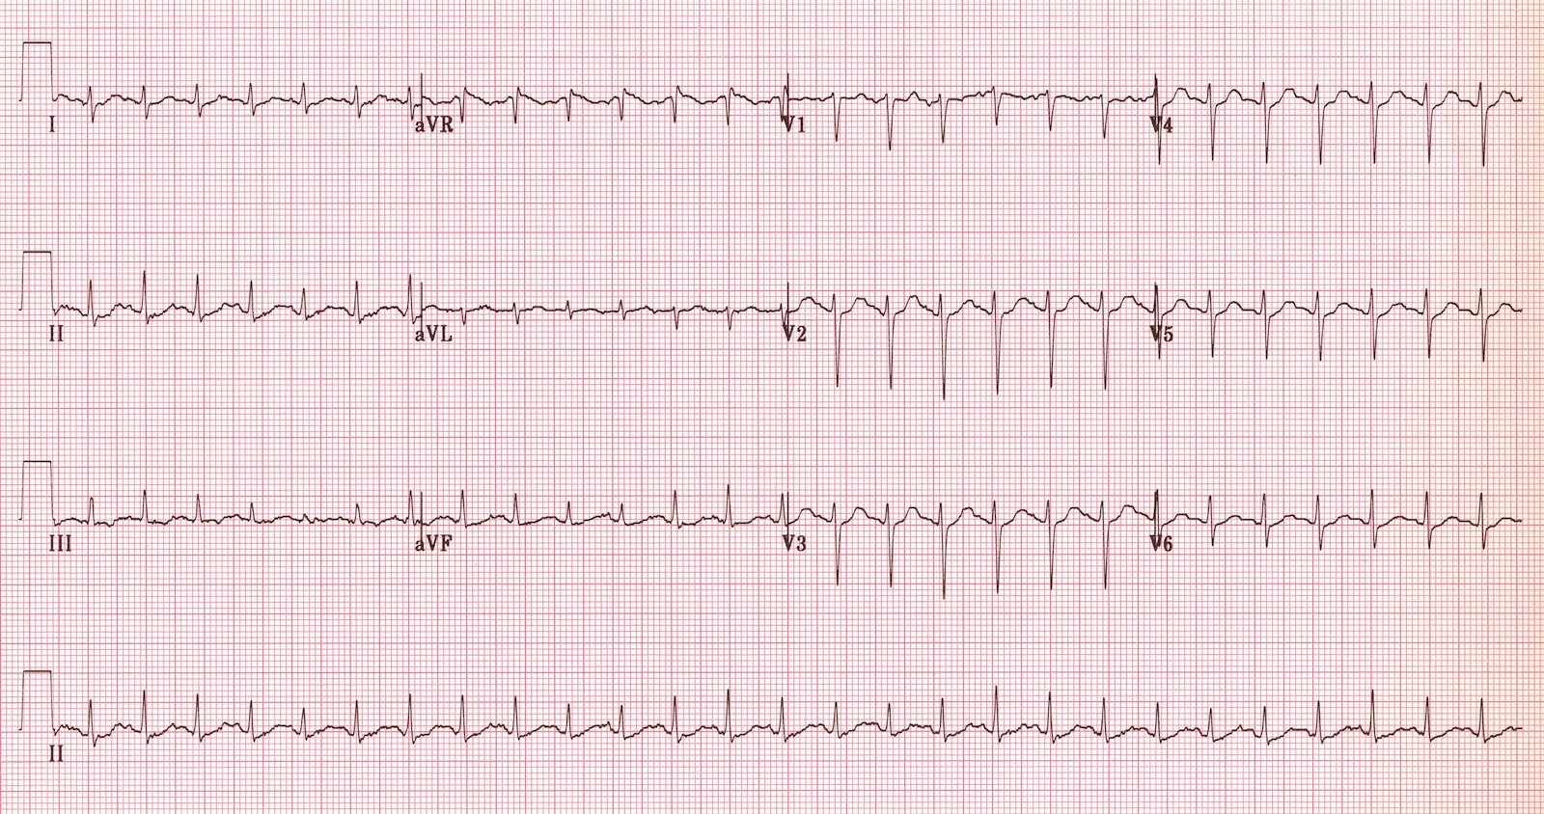  https://lifeinthefastlane.com/ecg-library/myocarditis/ | CXR – cardiomegaly, pulm edema  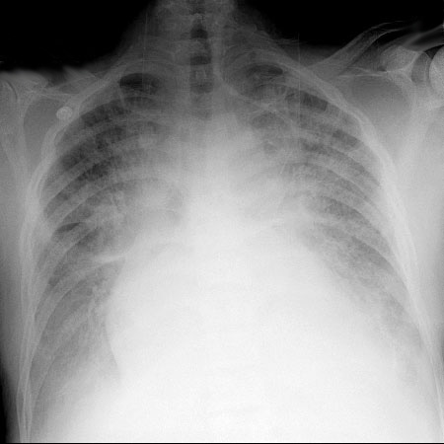  https://www.med-ed.virginia.edu/courses/rad/cxr/postquestions/posttest.html
POCUS (parasternal long) – Impaired EF  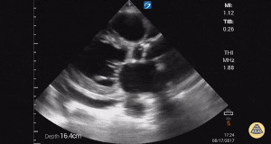  http://www.thepocusatlas.com/echo/xg2awokhx1zx8q3ndwjju5cu4t1adq | POCUS (lungs) – B-Profile  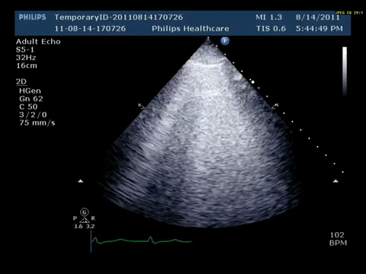  https://www.thoracic.org/professionals/clinical-resources/critical-care/clinical-education/quick-hits/orthopnea-in-a-patient-with-doxorubicin-exposure.php

Section VIII: Debriefing Guide

General Debriefing Plan
Individual |  | Group | With Video | Without Video
Objectives
Educational Goal: | To allow learners to practice identifying and managing cardiogenic shock in a critically ill adolescent
CRM Objectives: | - Demonstrates situational awareness by avoiding fixation error in a dynamic clinical situation  - Problem solving: considers alternative etiologies of shock when the patient is unresponsive to initial treatment
Medical Objectives: | - Recognizes a critically ill adolescent with cardiogenic shock  - Recalls and works through broad differential diagnosis of persistent hypotension  - Performs safe intubation  - Manages cardiogenic shock with inotropes
Sample Questions for Debriefing
Medical Knowledge
- What factors made (or could have made) intubation difficult? Did you assess these prior to attempting intubation?
- How did you optimize the patient prior to intubation? Would this change if you knew the patient had cardiogenic shock?
- Describe your differential for post-intubation hypotension. How do you work through this list?
- How do inotropes work? When would you consider using them in the ED?

CRM Skills
- How can you re-orient when a patient does not respond to treatment as you expect?
- What resources can you use when facing a diagnostic challenge?
- Do you (team leader) feel that you utilized your team members effectively? Does the team feel like they were used effectively?
Key Moments
Decision to intubate/Intubation planning
Recognizing myocarditis/cardiogenic shock
Providing inotropic support/hemodynamic optimization

