Section 1: Case Summary

Scenario Title: | Hypercalcemia
Keywords: | Hypercalcemia, malignancy, bad news
Brief Description of Case: | A 63-year-old male with stage 4 metastatic small cell lung cancer, presents to the ED with his wife. He is confused, and his wife says that he has been nauseous, constipated, and increasingly fatigued over the past week.  He was first diagnosed with lung cancer 5 years ago and was in remission until recently when he was recently diagnosed with recurrent disease. He is not currently on treatment but has an upcoming appointment with oncology.

Goals and Objectives
Educational Goal: | To seek out goals of care information in an oncology patient, and to treat acute complications of malignancy accordingly
Objectives:  (Medical and CRM) | CRM Objectives:  - Compassionately discuss bad news with patient’s family, recognizing the limitations of prognostication within the ED  - Initiate a goals of care discussion with substitute decision maker to determine appropriate disposition  Medical objectives:  - Order appropriate labs and diagnostic imaging workup for an elderly oncology patient presenting with confusion  - Recognize the signs and symptoms of hypercalcemia in an oncology patient  - Initiate emergency medical treatment for hypercalcemia of malignancy
EPAs Assessed:

Learners, Setting and Personnel
Target Learners: | ☒ Junior Learners |  | ☒ Senior Learners |  |  | ☐ Staff
Target Learners: | ☒ Physicians | ☐ Nurses |  | ☐ RTs | ☐ Inter-professional
Target Learners: | ☐ Other Learners:
Location: | ☒ Sim Lab |  | ☒ In Situ |  |  | ☐ Other:
Recommended Number of Facilitators: | Instructors: 1
Recommended Number of Facilitators: | Embedded Actors: 1-2
Recommended Number of Facilitators: | Sim Techs: 1

Scenario Development
Date of Development: | 31/03/2019
Scenario Developer(s): | Dr Skye Crawford, Dr Nathan Ashmead
Affiliations/Institutions(s): | University of British Columbia (UBC)
Contact E-mail: | lskyec@alumni.ubc.ca, nateashmead@gmail.com
Last Revision Date: | June 3, 2020
Revised By: | Dr Noorin Walji, Dr Chris Heyd
Version Number: | 2

Section 2A: Initial Patient Information

- Patient Chart
Patient Name: Greg Hanson |  |  |  | Age: 63 | Gender: M | Weight:
Presenting complaint: Confusion – metastatic Lung Ca
Temp: 37.0 | HR: 60 | BP: 88/50 |  | RR: 18 | O₂Sat: 94% | FiO₂: room air
Cap glucose:5.4 mmol/L |  |  |  | GCS: 14 (E4 V4 M6)
Triage note:
Stage 4 metastatic lung cancer. Wife states he has been progressively confused, nauseous, constipated, and fatigued over the past week.

Allergies: NKDA
Past Medical History:  Lung CA – treated 5 years ago. Recently diagnosed with recurrence. Not currently on treatment. Awaiting appointment with oncology  HTN  Dyslipidemia  Remote appendectomy |  |  | Current Medications:  Hydromorphone 1-2mg PO q4h PRN  Rosuvastatin  HCTZ  ASA
Social History: Lives at home with his wife

Section 2B: Extra Patient Information

A. Further History
Include any relevant history not included in triage note above. What information will only be given to learners if they ask? Who will provide this information (mannequin’s voice, actors, SP, etc.)?

- Cancer status – diagnosed with Small Cell lung cancer 5 years ago and received curative intent chemotherapy at the time. Over the last few months, he started to develop progressive SOB and pain, and imaging revealed recurrence of the disease. He is not currently on any disease-modifying therapy but has an appointment with oncology this week. [Paramedic]
- Code status – she is not sure but thinks her husband would want ‘everything done.’ Because they have not seen the oncologist, they have no idea about prognosis. She is understandably anxious about this and is asks questions looking for clarification. [Wife]

B. Physical Exam
List any pertinent positive and negative findings
Cardio: Nil | Neuro: Alert and oriented to person and place but not time. GCS 14
Resp: Nil | Head & Neck: Dry mucous membranes
Abdo: Generalized vague abdominal discomfort | MSK/skin: Low back pain (L4-5) – vertebral mets
Other:

Section 3: Technical Requirements/Room Vision

A. Patient
☒ Mannequin – ADULT
☐ Standardized Patient
☐ Task Trainer
☐ Hybrid
B. Special Equipment Required
Standard monitors
Nasal prongs
C. Required Medications
Bisphosphonate – Zoledronic acid. Pamidronate
Calcitonin

D. Moulage
N/A
E. Monitors at Case Onset
☒ Patient on monitor with vitals displayed
☐ Patient not yet on monitor
F. Patient Reactions and Exam
Include any relevant physical exam findings that require mannequin programming or cues from patient
(e.g. – abnormal breath sounds, moaning when RUQ palpated, etc.) May be helpful to frame in ABCDE format.

Airway: nil
Breathing: nil
Circulation: moaning on abdominal exam – generalized, no specific region
Disability: GCS 14 (E4V4M6) – not oriented to time, place
Exposure: L4/5 tenderness to palpation

Section 4: Embedded Actors and Standardized Patients

Embedded Actor and Standardized Patient Roles and Scripts
Role | Description of role, expected behavior, and key moments to intervene/prompt learners. Include any script required (including conveying patient information if patient is unable)
Paramedic | - If asked more details about his cancer diagnosis and treatment status: According to his wife, Mr. Hanson was first diagnosed with lung cancer 5 years ago and received curative intent chemotherapy at the time. Over the last few months, he started to develop progressive SOB and pain, and imaging revealed recurrence of the disease. He is not currently on any disease-modifying therapy but has an appointment with oncology this week.
Wife | - If asked about code status: “I’m not sure but I think he would want everything done. We are waiting to see the cancer doctor.”  - Results of CXR/ECG/CGT: Anxious, wants to know what is happening  - Initiation of hyperCa treatment: Wants to know what the diagnosis for hyperCa means for her husband’s prognosis

Section 5: Scenario Progression

Scenario States, Modifiers and Triggers
Patient State/Vitals | Patient Status | Learner Actions, Modifiers & Triggers to Move to Next State |  | Facilitator Notes
1. Baseline State  Rhythm: NSR  HR: 60 bpm  BP: 88/50  RR: 18/min  O₂SAT: 94%  T: 37ºC  GCS: 14 | Stable but confused | Expected Learner Actions  Cardioresp monitors  IV fluid bolus  Bedside cap glucose and temp  Obtain 12-lead ECG  Order labs  Order CXR and CT head | Modifiers  Changes to patient condition based on learner action  1L IVF BP 100/65  Triggers  For progression to next state  - All actions complete or 5 minutes | Participants should order an appropriate delirium work-up for an elderly oncology patient
2. Wife arrives  HR: 60 bpm  BP: 100/65  RR: 18/min  O₂SAT: 94%  T: 37ºC  GCS: 14 | Wife arrives, asks for an update and requests to stay at the bedside | Expected Learner Actions  Explain to wife that patient is still undifferentiated and the team is trying to figure out underlying issue  Ask about goals of care | Triggers  - Discussion with wife complete
3. Results Back  Vital signs remain stable |  | Expected Learner Actions  Recognize lung mets on CXR  Recognize short QT on ECG  Recognize elevated Ca on VBG | Modifiers  - ECG, imaging results given  Triggers  - Results reviewed
4. Initiate hyperCa treatment  Vital signs remain stable | If does not recognize hypercalcemia, phone call to sim lab with a critical lab result | Expected Learner Actions  Fluids: NS IV 200-300mL/hr  Bisphosphonate  1. Zoledronic acid OR  2. Pamidronate  Calcitonin | Modifiers  - Lab results given  Triggers  - Recognizing hypercalcemia, treatments ordered | See facilitator notes for medication dosing
5. Deliver bad news and initiate discussion around goals of care  Vital signs remain stable | Wife is upset and wants to know what the diagnosis of hypercalcemia means for her husband’s prognosis. | Expected Learner Actions  SPIKES  Explain that hypercalcemia is a sign of cancer progression  Explain that we do not have the full picture in the ED  Clarify that patient would want admission for further in-patient work-up and GoC discussion | Triggers  - Completed discussion with wife
6. Disposition  Vital signs remain stable |  | Expected Learner Actions  Admit to hospitalist/IM/ oncology  Palliative care consult with permission from wife | End of Case | Substitute facility-appropriate services

Appendix A: Laboratory Results

VBG
Glucose Random 6.9 (3.8-11.0 mmol/L)
Sodium 136 (135-145 mmol/L)
Potassium 4.2 (3.5-5.0 mmol/L)
Chloride 102 (98-107 mmol/L)
Lactate 2.8 (0.5-2.2 mmol/L)
Ionized Calcium 2.42 (1.16-1.29 mmol/L)
pH 7.33 (7.32-7.42)
pCO2 39 (38-50 mmHg)
pO2 21
Bicarb (Calc) 29 (24-30 mmol/L)

Appendix B: ECGs, X-rays, Ultrasounds and Pictures

Paste in any auxiliary files required for running the session. Don’t forget to include their source so you can find them later!

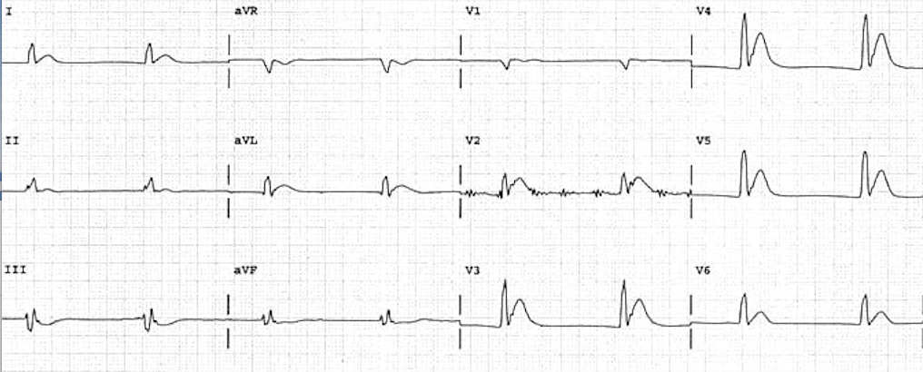
Reference: Life in the Fast Lane (https://lifeinthefastlane.com/ecg-library/basics/hypercalcaemia/)

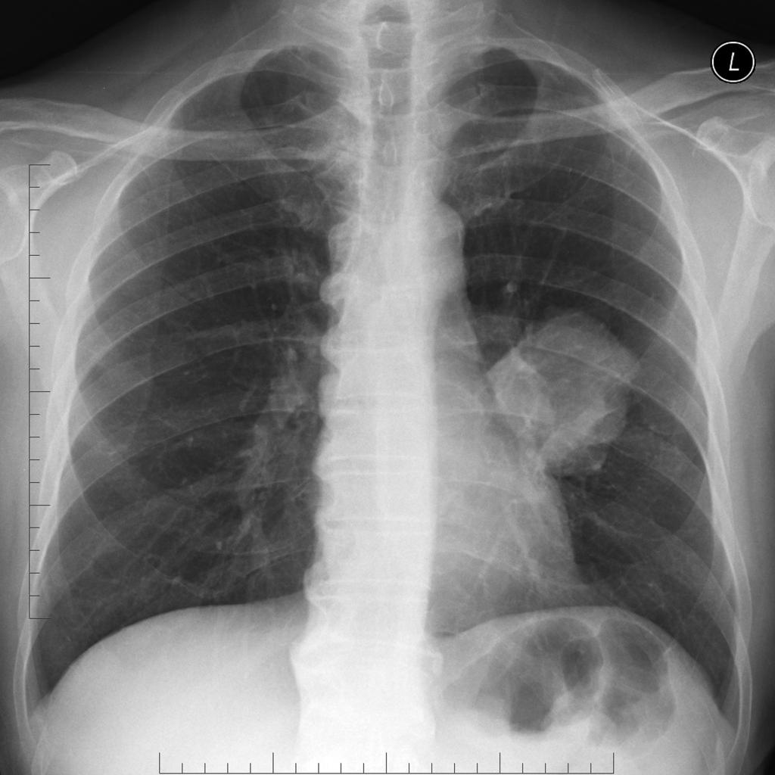
Reference: Radiopaedia (https://radiopaedia.org/cases/lung-cancer-10?lang=us)

Appendix C: Facilitator Cheat Sheet & Debriefing Tips

Key moments to watch:
- Broad workup for altered mental status in cancer patients
- Recognition of elevated calcium and appropriate treatment
- Discussion with wife about prognosis

Questions for debriefing:
- Why was this patient’s diagnosis difficult? What are the main symptoms of hypercalcemia?
  - Symptoms are often vague and non-specific
  - Stones (renal), bones (pain), abdominal groans (n/v, constipation), psychiatric overtones (lethargy, fatigue, confusion, psychosis)
- What is your approach to delivering bad news in the ED? What are some published systems?
  - SPIKES well known but not the only approach
- How do you answer family members who want a prognosis in the ED?
  - Rarely have all the information
  - Often need specialist guidance for nuances to treatment and prognosis
  - Can help patients and families navigate the system/know what steps to expect next

Pathophysiology Questions
- What are the ECG findings of hypercalcemia?
  - Shortened QT +/- ST elevation. In severe cases can have sinus bradycardia, BBB and high degree AV block
- What are the causes of hypercalcemia of malignancy?
  - Ectopic secretion of PTH
  - Multiple Myeloma
  - Cancer metastasis bone (most commonly breast, lung, hematologic, kidney and prostate)
- Treatment of hypercalcemia
  - Fluids – NS inhibits proximal tubule reabsorption of Ca and will correct volume depletion give bolus initially to stabilize BP then rate ~200-300mL/hr depending on co-morbidities. Urine output goal ~2L/day
  - Bisphosphonates (avoid if GFR <30)- reduce osteoclast-mediated bone resorption
    - Zoledronic acid 4-8mg IV over 15 mins (preferred in cancer patient)
    - Pamidronate 90mg over 2 hours
  - Calcitonin 4U/kg SC
  - Diuretics
    - Lasix does not enhance Ca elimination but can be used to augment saline diuresis
  - Denosumab (safe in renal failure, if refractory to bisphosphonates, not typically used in ED)

Breaking Bad News
- S – Setting: minimize distractions, sit down if possible +/- social worker
- P – Perception: What do they understand so far
- I – Invitation: Would the family like further information
- K – knowledge: provide information in a direct way using plain language
- E – Emotions: respond to family member’s emotions empathetically
- S – Summarize: Summarize and set out plan of action +/- strategize for next steps in line with GOC

References
- Sohi R, Sheppard G. Hypercalcemia of Malignancy: An Emergency Medicine Simulation. Cureus. 2017 Nov 15;9(11):e1847. doi: 10.7759/cureus.1847. PMID: 29348990; PMCID: PMC5768318.
- Baile WF, Buckman R, Lenzi R, Glober G, Beale EA, Kudelka AP. SPIKES-A six-step protocol for delivering bad news: application to the patient with cancer. Oncologist. 2000;5(4):302-311. doi:10.1634/theoncologist.5-4-302

