Section 1: Case Summary

Scenario Title:
Keywords: | Tracheostomy Emergency, Tracheoinnominate Artery Fistula, Hemoptysis
Brief Description of Case: | A 50 y/o obese M with recent tracheostomy 4 weeks prior placed for severe, recalcitrant obstructive sleep apnea presents by EMS after sudden onset brisk bleed from his tracheostomy tube.

Goals and Objectives
Educational Goal: | To allow learners to identify and temporize a tracheoinnominate artery fistula, a rare but life-threatening complication of tracheostomies. This is a high acuity, low opportunity presentation requiring complicated airway management, hemorrhage resuscitation and prompt set up of life-saving maneuvers to stabilize the patient. Review of tracheostomy equipment & anatomy.
Objectives:  (Medical and CRM) | CRM Objectives:  - Task delegation (simultaneous patient management and family discussion)  - Closed loop communication  - Anticipate and plan for a critically unwell patient  - Call for help early: Establish communication with consultants early for definitive management  - Anticipate/Preparation: RT, specialists (general surgery, vascular, ENT), nursing, second provider, massive transfusion protocol activation
EPAs Assessed: | C1 – Resuscitating and coordinating care for critically ill patients  C3 – Providing airway management and ventilation  C5 – Identifying and managing patients with emergent medical or surgical conditions  C100 – Describing the indications and performance of rare, critical procedures

Learners, Setting and Personnel
Target Learners: | ☐ Junior Learners |  | ☒ Senior Learners |  |  | ☒ Staff
Target Learners: | ☒ Physicians | ☒ Nurses |  | ☒ RTs | ☐ Inter-professional
Target Learners: | ☐ Other Learners:
Location: | ☒ Sim Lab |  | ☒ In Situ |  |  | ☐ Other:
Recommended Number of Facilitators: | Instructors: 1-2
Recommended Number of Facilitators: | Confederates: 0
Recommended Number of Facilitators: | Sim Techs: 1

Scenario Development
Date of Development: | 01 / 12 / 20
Scenario Developer(s): | Brandon Evtushevski & Jared Baylis
Affiliations/Institutions(s): | University of British Columbia, Departments of Emergency
Contact E-mail: | Brandon.chev@gmail.com
Last Revision Date:
Revised By:
Version Number:

Section 2A: Initial Patient Information

- Patient Chart
Patient Name: Jeremy Jones |  |  |  | Age: 55 | Gender: M | Weight: 150 kg
Presenting complaint: Blood per tracheostomy
Temp: 36.8 ºC | HR: 130/min | BP: 100 / 87 |  | RR: 30 | O₂Sat: 92% | FiO₂: 100% NRB
Cap glucose: 7 mmol/L |  |  |  | GCS: 14 (E4 V3 M6 )
Triage note:
EMS called by partner after spontaneous frank red blood per tracheostomy tube 40 min ago. Stopped on initial assessment but now increased red blood output again on route to hospital. Difficulty breathing, agitated. 10 minutes out.

Allergies: None
Past Medical History:  -Obesity (BMI 40)  -Severe OSA – failed CPAP; recent tracheostomy 4 weeks prior for surgical management of OSA  -Hypertension  -T2DM |  |  | Current Medications:  -Hydrochlorothiazide  -Metformin

Section 2B: Extra Patient Information

A. Further History
Include any relevant history not included in triage note above. What information will only be given to learners if they ask? Who will provide this information (mannequin’s voice, confederate, SP, etc.)?

EMS patch can provide further information (as discussed with patient’s partner)
-Goals of care: C2 (full code)
-Surgery 4 weeks ago by ENT; no laryngectomy (i.e. full anatomic connection airway). Surgical complication of “low-lying” tracheostomy secondary to short neck; no post-op complications in hospital, discharged after 1 week in hospital where educated re: tracheostomy care.
-One 18 gauge IV secured, right antecubital fossa
B. Physical Exam
List any pertinent positive and negative findings
Cardio: Heart sounds normal, no extra sounds, tachycardic | Neuro: GCS 14. Appears agitated.
Resp: #8 DCT, uncuffed tracheostomy in situ. Frank red blood per tracheostomy, on-going. Coughing with ineffective ventilation through tracheostomy. Wheeze throughout with crackles, no air entry deficits | Head & Neck: Oropharynx small red blood. Neck as described in Resp.
Abdo: Obese. Soft, non-tender. | MSK/skin: N/A
Other: N/A

Section 3: Technical Requirements/Room Vision

A. Patient
☒ Mannequin – adult, male (not required, but surgical airway capability is a pro as can have tracheostomy tube in situ)
☐ Standardized Patient
☐ Task Trainer
☐ Hybrid
B. Special Equipment Required
PPE
Gloves
Stethoscope
NIBP cuff / Pulse oximeter
Cardiac monitor
IV Bags/Lines
IV Push Medications
Nasal Prongs
Non-Rebreather Mask
Bag Valve Mask
Laryngoscope
ET/NG/OG Tubes
Tracheostomy tubes, uncuffed + cuffed
Standard airway equipment
Advanced airway equipment
Suction + inline suction catheters
Resuscitative cannulas – large bore IV, Cordis, etc
C. Required Medications
RSI & dissociative medications
Blood & massive transfusion protocol
Oxygen
Push dose phenylephrine, epinephrine
D. Moulage
If possible, tracheostomy in situ with blood around neck & per tracheostomy.
E. Monitors at Case Onset
☐ Patient on monitor with vitals displayed
☒ Patient not yet on monitor
F. Patient Reactions and Exam
Include any relevant physical exam findings that require mannequin programming or cues from patient
(e.g. – abnormal breath sounds, moaning when RUQ palpated, etc.) May be helpful to frame in ABCDE format.
A: Can’t speak (tracheostomy, no speaking valve), choking, coughing. If tracheostomy tube removed, massive hemoptysis per mouth continues.
B: Respiratory distress on arrival, wheeze throughout lungs
C: Peripheral pulses weak
D: GCS fluctuating
E: Normal
Section 4: Confederates and Standardized Patients

Confederate and Standardized Patient Roles and Scripts
Role | Description of role, expected behavior, and key moments to intervene/prompt learners. Include any script required (including conveying patient information if patient is unable)
Paramedic | Gives initial description of patient to team as other paramedics transfer patient to trauma bay bed:  ‘This is Jeremy, 55 y/o M recent tracheostomy placement 4 weeks ago for failed outpatient management of OSA. Sudden onset blood per tracheostomy at 13:20 that initially stopped for 10 minutes however now has resumed and increased - ~500mL estimated blood loss. The patient is on no anticoagulants. We have been unable to control the bleeding. Has become more agitated en route. Attempted to supplement breathing with oxygen via facemask and to tracheostomy tube – 92% O2 sat with 100% NRB & mask to tracheostomy tube. Secured x1 18G IV R antecubital fossa. Vital signs en route: 36.8 ºC, HR 130/min, BP 100/80, RR 30, O₂Sat: 92%, Cap Glu 7mmol/L, GCS M6, E4, Verbal unable to be assessed. Becoming more agitated. Partner on his/her way.”
Resus Nurse | Hooks patient up to monitors, provides additional vitals if requested.
Respiratory therapist | Applies O2 to face w/ facemask & facemask to tracheostomy tube if asked.  Suctions frank red blood from tracheostomy tube with suction catheter.
Partner | Doesn’t arrive until end of case.
ENT/Vascular/Thoracic Surgery (consult via phone) | When called, agrees to meet in OR STAT for definitive treatment (innominate artery ligation) if patient can be transferred to OR with hemorrhage control on-going.

Section 5: Scenario Progression

Scenario States, Modifiers and Triggers
Patient State/Vitals | Patient Status | Learner Actions, Modifiers & Triggers to Move to Next State |  | Facilitator Notes
1. Pre-Arrival & Preparation | En Route (10 min out) | Expected Learner Actions  Gathers team & delegates anticipated initial tasks (RT, Nurse, 2nd provider)  Anticipation of priorities: difficult airway, hemorrhage control, hemorrhage resuscitation, definitive treatment likely OR  Activates massive transfusion protocol (if not done, nursing can suggest)  Recognizes role of dissociative agents (e.g. Ketamine) to facilitate resuscitation | Modifiers  - Blood arrives prior to patient if O+ve requested  Triggers  - All actions complete or 5 min into case 2. Initial Resuscitation
2. Initial Resuscitation  Rhythm: Sinus tach  HR: 130/min  BP: 100/84  RR: 33  O₂SAT: 92%  T: 36.9ºC  GCS: Unable to assess | Distressed, appears agitated | Expected Learner Actions  Monitors  Additional vascular access – 2nd IV or femoral cordis  Primary Assessment – recognizes airway, breathing & circulatory compromise  Recognize further definitive airway control required, secondary to unprotected airway (on-going blood aspiration)  Recognize and voice likely tracheoinnominate artery fistula (TIF) bleed  Tamponade suspected TIF bleed with pressure – Utley maneuver (see Step 4)  Recognize lack of cuff on tracheostomy tube to facilitate tamponade initially  Level 1 transfuser, warmed blood  Page surgeon STAT for definitive OR therapy | Modifiers  - If does not recognize TIF, but rather massive hemoptysis then tracheostomy tube becomes clogged and unable to suction forcing crash airway scenario  - Able to call anesthesia for airway assistance or designate 2nd provider this task  - If exchange tracheostomy tube w/ cuffed one, bleed will be on-going forcing oral intubation to fully secure airway  - Alternatively #6 ETT can be utilized for intubation through tracheostomy, however unable to perform Utley maneuver (move to step 4)  - Can call for labs or portable CXR but won’t arrive in time except for VBG (waiting for labs/imaging will distract from immediate critical actions/procedures required)  Triggers  - Decision made to secure further definitive airway and dissociate patient for on-going care OR  - 10 min into case tracheostomy becomes clogged unable to exchange or suction forcing Step 3 |  | - For visual of patient as do Primary Survey, display image #1
3. Definitive Airway Control |  | Expected Learner Actions  Recognize difficult airway – soiled airway, obese, physiologic difficult airway (hemodynamically unstable). Ability to provide some ventilation through tracheostomy.  Difficult airway plan voiced  Choose hemodynamically “stable” RSI medications or utilizes phenylephrine peri-intubation  Recognize utility of intubating past suspected tracheal bleed to fully secure airway  Delegate intubation task or assume intubation and assign new leader to continue resuscitation  Post-intubation medications | Modifiers  - If suction not used, airway not visible  - If patient not positioned properly, Grade 3 view  - Any airway adjunct (except video) can be utilized to secure airway as first pass success if prepared properly  Triggers  - 10 min into step 3 intubated or ENT/Vascular/Thoracic calls suggesting TIF & intubate past bleed required for definitive airway control |  | Airway Plan Should Consider:  - Crash airway  - Soiled airway  - Obese  - Physiologic difficult airway (hemodynamically unstable)  - Ability to provide some salvage ventilation through tracheostomy PRN
4. Attempt Hemorrhage Control |  | Expected Learner Actions  Recognizes Utley Maneuver – HALO procedure (removes tracheostomy tube, inserts finger into trachea via tracheostomy and pulls anteriorly to attempt to tamponade innominate artery against posterior sternum) | Modifiers  - Utley maneuver performed bleeding temporized (stops/mild on-going)  - If #6 ETT inserted into tracheostomy instead of oral intubation aggressive volume resuscitation must be continued as salvage therapy on route to OR for definitive hemorrhage control  Triggers  - All actions complete or 5 min & surgeon suggests Utley manneuver en route to OR 4. Transfer to OR  -
5. Transfer to OR STAT |  | Expected Learner Actions  Recognize need to transfer to OR STAT for definitive management  Patient unhooked from ventilator and manual BVM en route to OR | Modifiers  - Bleeding temporized, hemodynamics stable with blood transfusions on-going  Triggers  - Transfer to OR End case

Appendix A: Laboratory Results

VBG
pH 7.24
pCO₂ 36
pO₂ 60
HCO₃ 17
Lactate 4 (H)

Appendix B: ECGs, X-rays, Ultrasounds and Pictures

Paste in any auxiliary files required for running the session. Don’t forget to include their source so you can find them later!

Image #1 – Visual for Initial Resuscitation

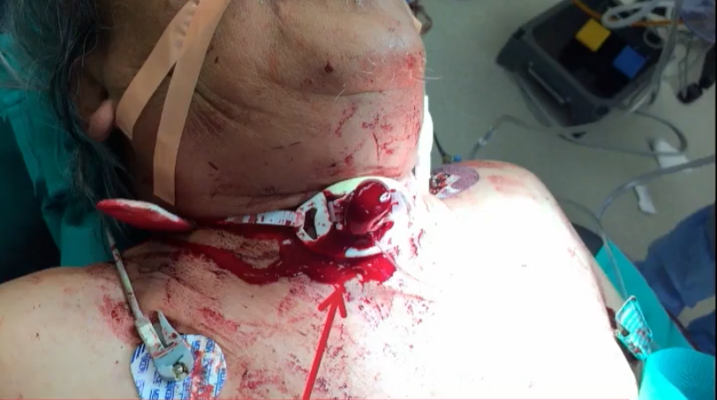Image source: K. Inaba. “Bleeding Tracheostomy” Essentials of Emergency Medicine, Live Presentation. Sept 20, 2016. (note: patient is NOT intubated yet)

Image #2, 3, 4 (for debrief) – Tracheo-innominate Artery Fistula Anatomy

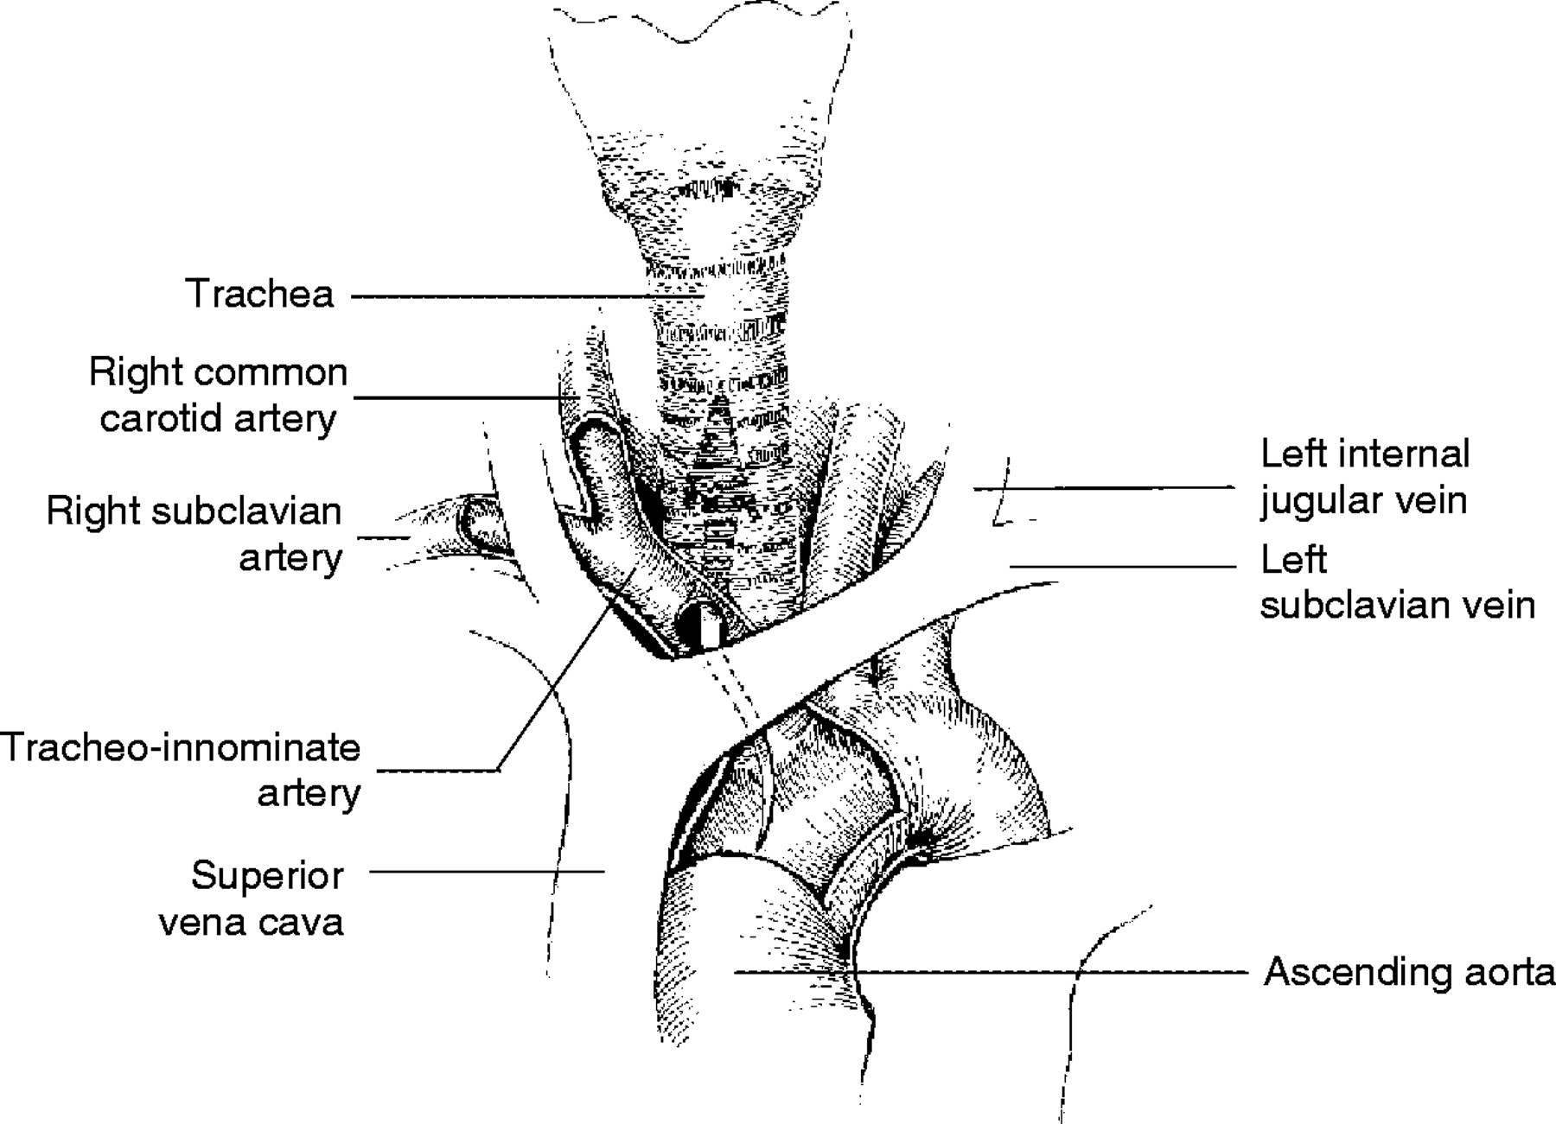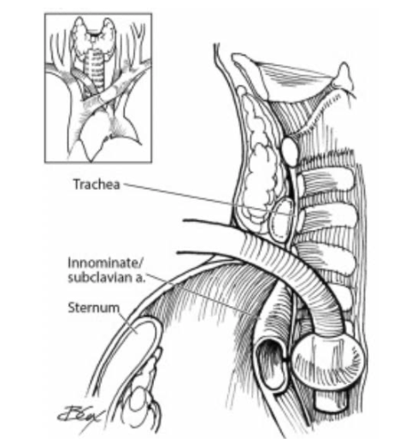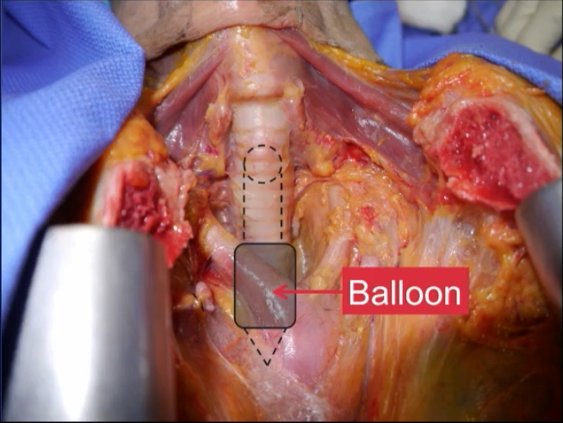

Image Sources (from right to left):
- O. Schaefer & R. Irwin. Tracheoarterial Fistula: An Unusual Complication of Tracheostomy. J Intensive Care Med. 1995 10: 64
- C. Pool & N. Goyal. Operative management of catastrophic bleeding in the head and neck. Oper Tech Otolaryngol Head Neck Surg. 2017. 28(4):220-228.
- K. Inaba. “Bleeding Tracheostomy” Essentials of Emergency Medicine, Live Presentation. Sept 20, 2016. (note: patient is NOT intubated yet)

Image #5 (for debrief) – Utley Maneuver
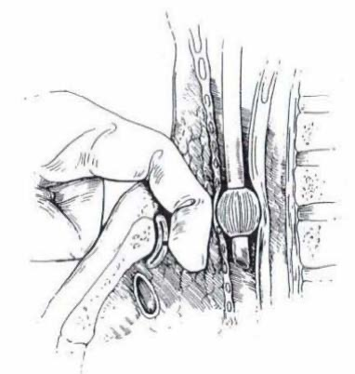
Image source: http://www.downstatesurgery.org/files/cases/tif.pdf

Appendix C: Facilitator Cheat Sheet & Debriefing Tips

Include key errors to watch for and common challenges with the case. List issues expected to be part of the debriefing discussion. Supplemental information regarding any relevant pathophysiology, guidelines, or management information that may be reviewed during debriefing should be provided for facilitators to have as a reference.

Debriefing as a group, without video.

Sample questions for debriefing:

CRM
- How could preparation & anticipation have assisted with an unstable patient in the field?
- How do you prioritize interventions & procedures in a crashing patient?
- How do you deal with diagnostic uncertainty in a crashing patient?
- How do you navigate unfamiliar equipment (i.e. tracheostomy tube equipment)?

Medical Expert
- What is a tracheoinnominate artery fistula?
- Direct connection between the native trachea and the innominate artery branch of the aorta often from tracheostomy hardware erosion into vasculature (see images # 2, 3, 4). Can’t miss diagnosis – must be thought of in all tracheostomy patients.
- RFs that raise suspicion for TIF: low lying tracheostomy (>3 tracheal ring placement), placement of tracheostomy within last 4 weeks (75% occur during this time), sentinel bleed prior to massive hemorrhage (50% experience), frank red blood per tracheostomy, pulsation of tracheostomy tube, concurrent steroids or radiation Tx to neck, poor cuff care (pressure necrosis cuff [>20mmHg] or ++ manipulation], recent local infection [e.g. tracheitis]

- Priorities in suspected TIF?
- Definitive airway cuff BELOW level of bleed decreases blood aspiration & V/Q mismatching (orotracheal preferred as can still perform Utley maneuver)
- Hemorrhage resuscitation massive transfusion protocol & reverse any anticoagulation
- Tamponade bleeding if have CUFFED tracheostomy tube in situ, OVER-INFLATE cuff to 50cc slowly to tamponade and secure airway (~85% success rate). No cuff orotracheal intubation as step #1 and perform Utley maneuver.
Alternatives: Tracheostomy intubation w/ cuffed ETT #6 or attempt same sized cuffed tracheostomy tube insertion with overinflation
- Transfer to OR
- Which tracheostomy patients cannot be intubated orotracheally?
Laryngectomy patients, known obstructing upper airway lesion

- What is definitive treatment of TIF?
Operative innominate artery ligation. Stent and repair of artery are suboptimal as re-bleed rate too high.

- Incidence & Prognosis of TIF Bleed
Without OR: 100% mortality
With prompt identification, temporization, & OR intervention: 50% alive within 2 months

- Aside from TIF, other causes of massive hemoptysis?
SPITS mnemonic – structural (neoplasm), pulmonary (bronchitis, TB), Iatrogenic (post-lung biopsy), Thrombosis (PE, coagulopathy), Systemic (vasculitis, SLE) + Mimickers (GI, Epistaxis)

References

1. B. Long, A. Koyfman. Resuscitating the tracheostomy patient in the ED. American Journal of Emergency Medicine 34 (2016) 1148–1155.
2. B. Reger et al. High mortality in patients with tracheoarterial fistulas: clinical experience and treatment recommendations. Interact Cardiovasc Thorac Surg. 2018;26(1):12–17.
3. D. Goldenberg et al. Tracheotomy complications: A retrospective study of 1130 cases. Otolaryngology–Head and Neck Surgery (2000); Volume 123 Number 4.
4. K. Inaba. “Bleeding Tracheostomy” Essentials of Emergency Medicine, Live Presentation. Sept 20, 2016.

